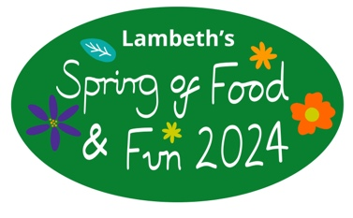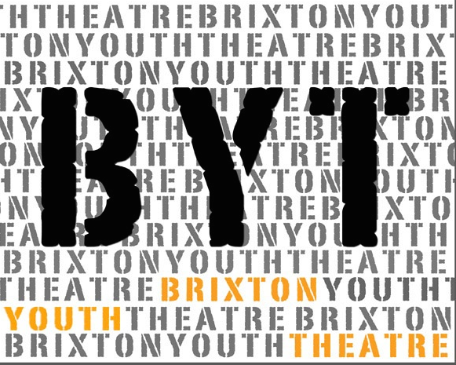
HAF Drama Spring 2024
Tuesday 2nd – Friday 5th April
Monday 8th and Tuesday 9th April
11am – 3pm

If there are any dates that you know you cannot attend please let us know.

Participant Application Form
Please fill in your details below to apply to join this project. Forms need to signed by a parent/guardian.
If you would like to find out more about this project please:
Email Caroline at carolinefunnell@btinternet.com or visit our website,
Or www.brixtonyouththeatre.com

First name
Surname
Address
Mobile phone number
Home phone number
Email address
School / College
Age |  |  | Date of Birth
Emergency Contact details:
- Name: Tel:
Medical Conditions/Special Requirements

Do you have any allergies: |  | No
Please let us know of any dietary requirements we should be aware of:
Please let us know of any access requirements or medical information we should be aware of:
Parent/Guardian consent (for participants under 16) |  | I give consent for this participant to attend Brixton Youth Theatre (BYT). Signature of parent/guardian:  ......................................................................
Photography & Video Consent by parent/guardian |  | I give consent for this participant to be photographed and/or filmed Images and video may be used to promote BYT activities and future projects, including on BYT website and social media platforms. No names will be used. Signature of parent/guardian:  .........................…....……………………………
Parent/Guardian contact details |  | Name:
 |  | Email:
 |  | Mobile:
 |  | Home/work phone number:

Our funders often require statistics about the people participating in our projects. If you are happy to share these details, please complete the questions below.

Gender  Please circle |  | Female Male Prefer not to say
Ethnicity |  | Please tick one option below. These categories are specified by our main funders.
 | Turkish |  |  | Kurdish |  | Mixed Ethnicity
 | Pakistani |  |  | Black caribbean |  | White & Asian
 | Bangladeshi |  |  | Black Congolese |  | White I& Black British
 | Indian |  |  | Black Nigerian |  | White & Black Caribbean
 | Other Asian |  |  | Black Somali |  | Other mixed ethnicity
 | Chinese |  |  | Black British |  | White British
 | Moroccan |  |  | Black African |  | White Irish
 | Latin South American |  |  | Black Other |  | Albanian
 | Filipino |  |  | Iranian |  | Kosovan
 | Turkish Cypriot |  |  | Other Background |  | White European

Benefit Related Free School Meals
Refugee or Asylum Seeker
Child-Looked After or Under Special Guardianship
Claiming benefits
Without recourse to public funds
SEND/Additional needs (please give more information)

Return this form to:
carolinefunnell@btinternet.com or call Caroline to register 07958 448690

The project will take place at St Vincents Brixton, Talma Road SW2 1AS

