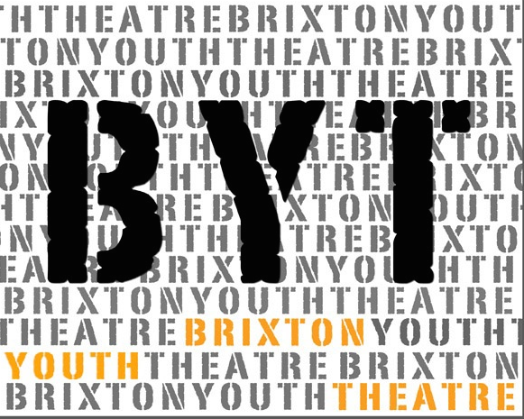
HAF Drama Project Spring 2023
Monday 24th July - Friday 28th July
Monday 31st July - Friday 4th August
11am – 3pm

Please tick which week you would like to attend
If you would like to attend both weeks tick both.
If there are any dates that you know you cannot attend please let us know.

On 27th July we are planning a trip to Kew Gardens to see Alice in Wonderland. All children will have free tickets. There will be no activities at the centre that day.

Participant Application Form
Please fill in your details below to apply to join this project and have the form signed by a parent/guardian.
If you would like to find out more about this project please:
Email Caroline at carolinefunnell@btinternet.com or visit our website,
Or www.brixtonyouththeatre.com

First name
Surname
Address
Mobile phone number
Home phone number
Email address
School / College
Age |  |  | Date of Birth
Emergency Contact details:
- Name: Tel:
Medical Conditions/Special Requirements

Do you have any allergies: |  | No
Please let us know of any dietary requirements we should be aware of:
Please let us know of any access requirements or medical information we should be aware of:
Parent/Guardian consent (for participants under 16) |  | I give consent for this participant to attend Brixton Youth Theatre (BYT). Signature of parent/guardian:  ......................................................................
Photography & Video Consent by parent/guardian |  | I give consent for this participant to be photographed and/or filmed Images and video may be used to promote BYT activities and future projects, including on BYT website and social media platforms. No names will be used. Signature of parent/guardian:  .........................…....……………………………
Parent/Guardian contact details |  | Name:
 |  | Email:
 |  | Mobile:
 |  | Home/work phone number:

Our funders often require statistics about the people participating in our projects. If you are happy to share these details, please complete the questions below.

Gender  Please circle |  | Female Male Prefer not to say
Ethnicity |  | Please tick one option below. These categories are specified by one of our main funders.
 | Turkish |  |  | Kurdish |  | Mixed Ethnicity
 | Pakistani |  |  | Black caribbean |  | White & Asian
 | Bangladeshi |  |  | Black Congolese |  | White I& Black British
 | Indian |  |  | Black Nigerian |  | White & Black Caribbean
 | Other Asian |  |  | Black Somali |  | Other mixed ethnicity
 | Chinese |  |  | Black British |  | White British
 | Moroccan |  |  | Black African |  | White Irish
 | Latin South American |  |  | Black Other |  | Albanian
 | Filipino |  |  | Iranian |  | Kosovan
 | Turkish Cypriot |  |  | Other Background |  | White European

Eligible for Free School Meals
Claiming benefits
Without recourse to public funds
A frontline worker
Vulnerable or disadvantaged in any way (please give more information)

Return this form to:
brixtoncommunitybase@gmail.com or call Caroline to register 07958 448690

The project will take place at The Wheatsheaf Community Hall (off SouthLambeth Road) SW8 2UP
https://www.wheatsheafhall.org.uk/directions/

OUTING TO KEW GARDENS JULY 27th 2023

We are providing free tickets for all the children attending to spend the day at Kew gardens and watch a performance of Alice in Wonderland www.theatreonkew.co.uk. There will also be the opportunity for them to meet the actors afterwards and take photos with them.

We will be travelling on public transport (mainline Vauxhall to Richmond – one stop district line to Kew Gardens)

This is a lovely day out for parents/carers and children and we will look at getting subsidised tickets for parents who want to come when we know how many people would like to join us.
https://www.kew.org/kew-gardens/families

There are two performances on that day. The group will attend at 2pm, but if you would like to make your own way there we can also arrange tickets for 11am.

Child would like to attend
Number of additional children
Number of adults
Performance time: 11am
Performance: 2pm

