Brixton Youth Theatre 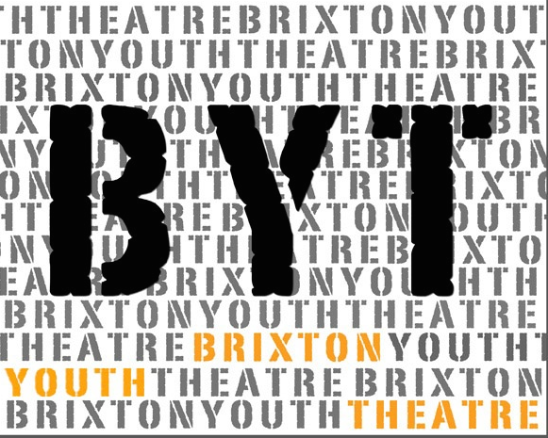
Every Friday 6pm – 8pm

Participant Application Form
Please fill in your details below to apply to join the Brixton Youth Theatre and have the form signed by a parent/guardian if you’re under 16.
If you would like to find out more about BYT please call: 07960 964558
Email info@brixtonyouththeatre.com or visit our website www.brixtonyouththeatre.com

First name
Surname
Address
Mobile phone number
Home phone number
Email address
School / College
Age |  |  | Date of Birth
Emergency Contact details:
- Name: Tel:

Which of the following are you interested in (please circle all that apply:)

Acting Movement/Dance Writing songs/words Composing music

Singing Filming Making Art/design Directing

Please tell us three reasons why you would like to join Brixton Youth theatre:

Medical Conditions/Special Requirements

Do you have any allergies?
Please let us know of any dietary requirements we should be aware of:
Please let us know of any access requirements or medical information we should be aware of:
Parent/Guardian consent (for participants under 16) |  | I give consent for this participant to attend Brixton Youth Theatre (BYT). Signature of parent/guardian:  ......................................................................
Photography & Video Consent by parent/guardian |  | I give consent for this participant to be photographed and/or filmed Images and video may be used to promote BYT activities and future projects, including on BYT website and social media platforms. No names will be used. Signature of parent/guardian:  .........................…....……………………………
Parent/Guardian contact details |  | Name:
 |  | Email:
 |  | Mobile:
 |  | Home/work phone number:

Our funders often require statistics about the people participating in our projects. If you are happy to share these details, please complete the questions below.

Gender  Please circle |  | Female Male Prefer not to say
Ethnicity |  | Please tick one option below. These categories are specified by one of our main funders.
 | Arab/North African |  |  | Black or Black British Caribbean |  | West European (please specify)
 | Arab/Asian |  |  | Black or Black British African |  | White British
 | Asian or Asian British Indian |  |  | Chinese |  | White Irish
 | Asian or Asian British Pakistani |  |  | East European (please specify) |  | White other (please specify)
 | Asian or Asian British Bangladeshi |  |  | Mixed other (please specify) |  | Unknown
 | Asian or Asian British other (please specify) |  |  | Other ethnic group (please specify)

Return this form to BYT in order to apply for the project. post or email to: Brixton Community Based Impact Brixton 17a Electric Lane London SW9 8LA / info@brixtonyouththeatre.com

