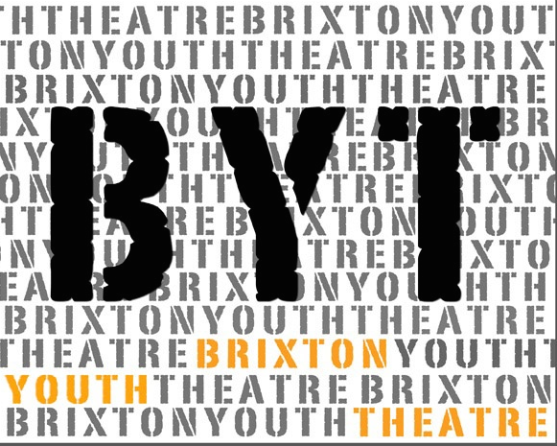
Drama Project
4-8th April 2022
11am-3pm

Participant Application Form
Please fill in your details below to apply to join this project and have the form signed by a parent/guardian.
If you would like to find out more about this project please:
Email Caroline at brixtoncommunitybase@gmail.com or visit our website, www.brixtoncommunitybase.org
Or www.brixtonyouththeatre.com

First name
Surname
Address
Mobile phone number
Home phone number
Email address
School / College
Age |  |  | Date of Birth
Emergency Contact details:
- Name : Tel:
Medical Conditions/Special Requirements

Do you have any allergies:
Please let us know of any dietary requirements we should be aware of:
Please let us know of any access requirements or medical information we should be aware of:
Parent/Guardian consent (for participants under 16) |  | I give consent for this participant to attend Brixton Youth Theatre (BYT). Signature of parent/guardian:  ......................................................................
Photography & Video Consent by parent/guardian |  | I give consent for this participant to be photographed and/or filmed Images and video may be used to promote BYT activities and future projects, including on BYT website and social media platforms. No names will be used. Signature of parent/guardian:  .........................…....……………………………
Parent/Guardian contact details |  | Name:
 |  | Email:
 |  | Mobile:
 |  | Home/work phone number:

Our funders often require statistics about the people participating in our projects. If you are happy to share these details, please complete the questions below.

Gender  Please circle |  | Female Male Prefer not to say
Ethnicity |  | Please tick one option below. These categories are specified by one of our main funders.
 | Turkish |  |  | Kurdish |  | Mixed Ethnicity
 | Pakistani |  |  | Black caribbean |  | White & Asian
 | Bangladeshi |  |  | Black Congolese |  | White I& Black British
 | Indian |  |  | Black Nigerian |  | White & Black Caribbean
 | Other Asian |  |  | Black Somali |  | Other mixed ethnicity
 | Chinese |  |  | Black British |  | White British
 | Moroccan |  |  | Black African |  | White Irish
 | Latin South American |  |  | Black Other |  | Albanian
 | Filipino |  |  | Iranian |  | Kosovan
 | Turkish Cypriot |  |  | Other Background |  | White European

Eligible for Free School Meals
Claiming benefits
Without recourse to public funds
A frontline worker
Vulnerable or disadvantaged in any way (please give more information)

Return this form to:
brixtoncommunitybase@gmail.com or call Caroline to register 07958 448690

The project will take place at St Vincents Brixton – Talma Road, Brixton London SW2 1AS

This is funded by Government HAF scheme and supported by St Vincent’s Brixton

