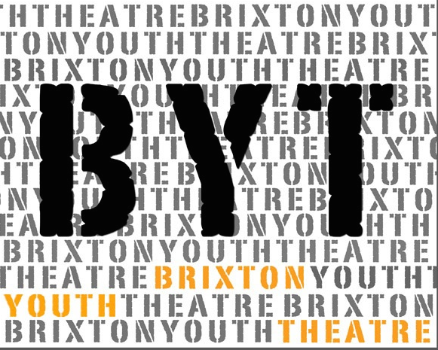
Winter HAF Drama Project
20th-23rd December 2021
7 - 11 yrs
11am-3pm

Participant Application Form
Please fill in your details below to apply to join this project and have the form signed by a parent/guardian.
If you would like to find out more about this project please:
Email Caroline at brixtoncommunitybase@gmail.com or visit our website, www.brixtoncommunitybase.org
Or www.brixtonyouththeatre.com

First name
Surname
Address
Mobile phone number
Home phone number
Email address
School / College
Age |  |  | Date of Birth
Emergency Contact details:
- Name : Tel:
Medical Conditions/Special Requirements

Do you have any allergies:
Please let us know of any dietary requirements we should be aware of:
Please let us know of any access requirements or medical information we should be aware of:
Parent/Guardian consent (for participants under 16) |  | I give consent for this participant to attend Brixton Youth Theatre (BYT). Signature of parent/guardian:  ......................................................................
Photography & Video Consent by parent/guardian |  | I give consent for this participant to be photographed and/or filmed Images and video may be used to promote BYT activities and future projects, including on BYT website and social media platforms. No names will be used. Signature of parent/guardian:  .........................…....……………………………
Parent/Guardian contact details |  | Name:
 |  | Email:
 |  | Mobile:
 |  | Home/work phone number:

Our funders often require statistics about the people participating in our projects. If you are happy to share these details, please complete the questions below.

Gender  Please circle |  | Female x Male Prefer not to say
Ethnicity |  | Please tick one option below. These categories are specified by one of our main funders.
 | Arab/North African |  |  | Black or Black British Caribbean |  | West European (please specify)
 | Arab/Asian |  |  | Black or Black British African |  | White British
 | Asian or Asian British Indian |  |  | Chinese |  | White Irish
 | Asian or Asian British Pakistani |  |  | East European (please specify) |  | White other (please specify)
 | Asian or Asian British Bangladeshi |  |  | Mixed other (please specify) |  | Unknown
 | Asian or Asian British other (please specify) |  |  | Other ethnic group (please specify) |  | African & Latin American

Eligible for Free School Meals
Claiming benefits
Without recourse to public funds
A frontline worker
Vulnerable or disadvantaged in any way (please give more information)

Return this form to:
brixtoncommunitybase@gmail.com or call Caroline to register 07958 448690

The project will take place at St Vincents Brixton – Talma Road, Brixton London SW2 1AS

This is funded by Government HAF scheme.
https://www.gov.uk/government/publications/holiday-activities-and-food-programme/holiday-activities-and-food-programme-2021

