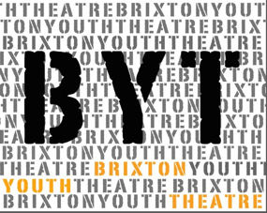

Participant Application Form – BYT 7-11
Please fill in your details below to apply to join this project and have the form signed by a parent/guardian.
If you would like to find out more about this project please:
Email Caroline at brixtoncommunitybase@gmail.com or visit our website, www.brixtoncommunitybase.org
Or www.brixtonyouththeatre.com

First name
Surname
Address
Mobile phone number
Home phone number
Email address
School / College
Age |  |  | Date of Birth
Emergency Contact details:
- Name: Tel:

Medical Conditions/Special Requirements

Do you have any allergies:
Please let us know of any access requirements or medical information we should be aware of:
Parent/Guardian consent (for participants under 16) |  | I give consent for this participant to attend Brixton Youth Theatre (BYT). Signature of parent/guardian:  ......................................................................
Photography & Video Consent by parent/guardian |  | I give consent for this participant to be photographed and/or filmed Images and video may be used to promote BYT activities and future projects, including on BYT website and social media platforms. No names will be used. Signature of parent/guardian:
Parent/Guardian contact details |  | Name:
 |  | Email:
 |  | Mobile:
 |  | Home/work phone number:

Our funders often require statistics about the people participating in our projects. If you are happy to share these details, please complete the questions below.

Gender  Please circle |  | Female Male Prefer not to say
Ethnicity |  | Please tick one option below. These categories are specified by one of our main funders.
 | Arab/North African |  |  | Black or Black British Caribbean |  | West European (please specify)
 | Arab/Asian |  |  | Black or Black British African |  | White British
 | Asian or Asian British Indian |  |  | Chinese |  | White Irish
 | Asian or Asian British Pakistani |  |  | East European (please specify) |  | White other (please specify)
 | Asian or Asian British Bangladeshi |  |  | Mixed other (please specify) |  | Unknown
 | Asian or Asian British other (please specify) |  |  | Other ethnic group (please specify)

Eligible for Free School Meals
Claiming benefits
Without recourse to public funds
Vulnerable or disadvantaged in any way (please give more information)

Return this form to:
brixtoncommunitybase@gmail.com or call Caroline to register 07958 448690
The project will take place at St Vincents Brixton – Talma Road, Brixton London SW2 1AS

This project is funded by:
Sir Walter St John's Educational Charity

